

A is for Apple

The EAGA Study of ACT and ACT-S

Margaret Anandala
Aliona Burlacu
Jesper Hagemeier
Louisa Heidelstadt
Mariatu Kamara
Dave Pieters
Jelena Vukas

Lead by: Sylvain FAGES

A is for Apple: the EAGA Study of ACT and ACT-S

Abstract

The purpose of this study was to conduct a long term study to separate key issues concerning ACT and its by-product ACT-S. The study was conducted over a period of nine months. It was conducted in controlled laboratory settings of the EAGA research facilities in Brussels.

The study observed and compared cases of cancer development in rats that were a) not ingesting any ACT or ACT-S, b) ingesting pure ACT with no ACT-S and c) that were ingesting high levels of ACT-S.

The results obtained suggest that ACT is not a risk but a possible benefit to the health and preservation of organisms. There is a need for further research in controlled settings in order to confirm these findings. Secondly, the results show that the by-product of ACT, ACT-S, is potentially dangerous but holds no statistical risk to consumers.

Introduction

Apples have been cultivated since the Neolithic period. They, as well as apple juice, have been known for many health benefits such as cleaning teeth and strengthening gums, lowering cholesterol and soothing stomach and ingestion problems. The study of Riu Hai Liu of Cornell University (2000), apple juice has been proven to destroy viruses in the body.

Despite all this, in Europe, controversy around the safety of ingesting apples treated with the ACT (acetylcysteinetriphospate) and apple juice byproduct ACT-S (acetylcysteinetriphospatesulphate) raised controversial debates as studies came out linking ACT to cancer.

In 2002, scientists at the Dutch Leiden University found a link that suggested ACT had caused cancer in small animals, rats to be exact. The usage of ACT was thereon discontinued by most of the apple growers represented in the European Apple Growers Association (EAGA).

Further enquiry into the matter was continued by European Resource Defence Council (ERDC) who conducted a study on pesticides and the affects of such on preschool children (2002). One of the pesticides tested was ACT, or rather the by-product, ACT-S.

Though flags had been raised, questions about ACT and ACT-S remain unanswered. There was need to conduct an experiment in a controlled environment over a longer period of time and look at a few different factors before any final decisions could be made. The EAGA felt that it owed its consumers to verify or disprove the potential dangers about ACT that had surfaced over the years.

ACT

ACT consists of three parts:

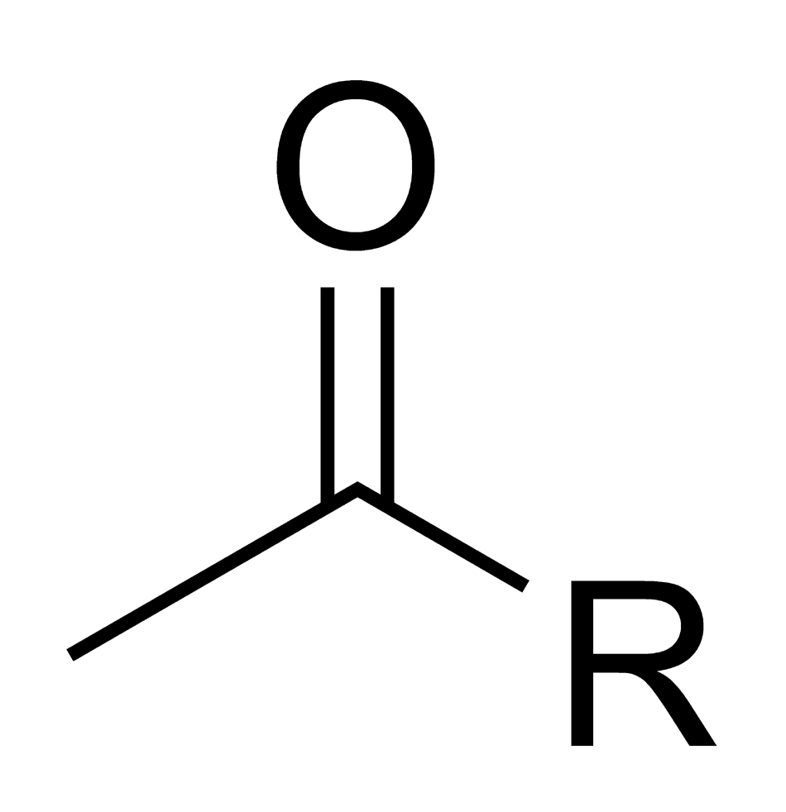
- Acetyl: this is a general denomination for a functional group that consists of a double bond between an oxygen and a carbon, which are linked to an “R” molecule. This “R” molecule is generally a carbon chain, but can contain any other functional group (acid, alcohol, amine, etc).
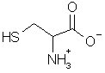
- Cysteine: one of the twenty main amino acids found in most proteins which makes the protein chain active. It is not naturally produced by the body but has to be ingested via, e.g. beta carotene. This molecule is compulsory for health.
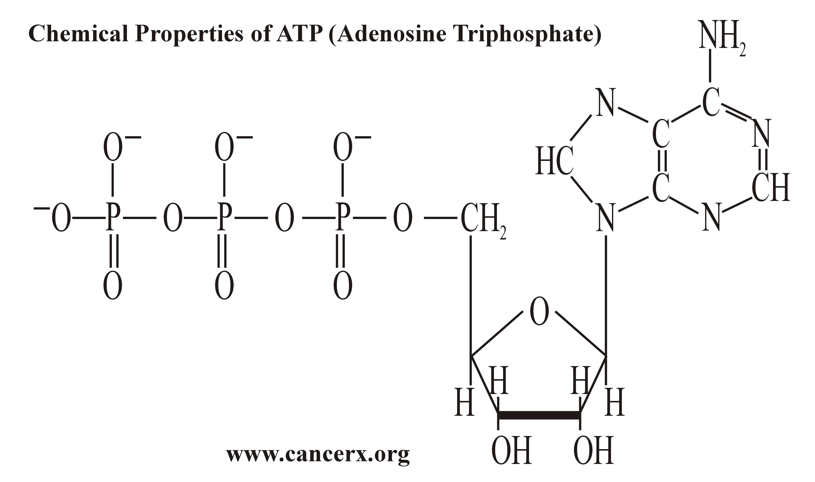
- Triphospate: This molecule is in fact the energy carrier in the human body when linked to adesine. The bond between two phosphates (P) is very energetic and will allow transporting energy trough the whole body.

ACT- S

It consists of the same parts of ACT with the addition of sulfate (SO₄). Sulfate is often used as a pesticide.

- SO₄
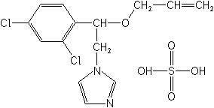

ACT-S is a by-product in the production of apple juice. It is created when the juice is pasteurized at 77°C during 30 min to kill all yeast and bacteria.

- ACT
2

The molecule R is a complex and irrelevant molecule as a whole. A reaction happens in a part of the molecule we named R1. R1 reacts with sulfate at high to give a complex R–S. Here is the reaction:

- Sulfate + R1 R-S + H₂O

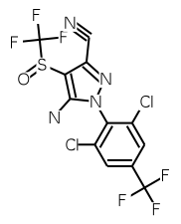
H₂O

4. ACT-S
2
Methods of Experiment

Testing subjects used in the experiments were albino laboratory rats (Rattus norvegicus, descendants of the mus musculus mouse). These species were used for two purposes: a) they had been used in the Leiden University experiment of 2002; b) they are model organisms- organisms which provide insight into the workings of other organisms, in this case primarily humans.

The two ACT and ACT-S testing groups were given a form of apple-descending food, in concentrate, three times a day over a period of nine months. The amount fed to the rats would be equivalent to a human ingesting ten liters of apple juice per week. This means that over a period of nine months the rats ingested an equivalent to a human ingesting 360 liters of apple products.

In order to verify or disprove the Leiden University experiment the EAGA research team studied their research and found some overlooked elements of research. The Leiden experiment had used the following procedure:

- Crush apples in a mixture
- Compress and add water heated to 70°C in order to heat and dissolve molecules
- Evaporate water to concentrate
- Feed to testing specimen

The procedure in our experiment was the same in order to possibly verify their findings by achieving the same results. Therefore our procedure was:

- Crush apples in a mixture
- Compress and add water heated to 70°C in order to dissolve molecules
- Evaporate water to create concentrate
- Feed to testing specimen

However a few elements were firstly differentiated between and measured. The first element was the important differentiation of ACT and ACT-S. We conducted an experiment observing the process of creating apple juice concentrate. We noticed that according to the regulations of creating apple juice concentrate, the temperature at which the molecules of apples are dissolved in Europe is 50°C. We therefore measured the amount of ACT and ACT-S present in the process of dissolving molecules at different temperatures.

To back up possibly different findings of ACT and ACT-S the testing specimen included: rats that were a) not ingesting any ACT or ACT-S, b) ingesting pure ACT with no ACT-S and c) that were ingesting high levels of ACT-S.

The procedure of creating ACT concentrate without getting the by-product, ACT-S, in the process was the following:

- Crush apples in a mixture
- Compress in vacuum in order to dissolve all molecules into concentrate
- Feed to testing specimen

The third group of rats that was observed was not ingesting apples nor any food items containing ACT or ACT-S.

Results

The first and foremost experiment conducted was to find the amount of ACT and ACT-S in the concentrate being fed to the testing specimen. The following table (Figure 1) shows the amount of ACT and ACT-S present in a mixture of crushed apples being treated with heated water which has been heated to different degrees.

Figure 1: Amount of ACT/ACT-S in the process of creating concentrate with heated water
Temperature of  Water °C | 20 | 50 | 70 | 100
Amount of ACT  % | 99 | <98 | 84 | 70
Amount of ACT-S % | 1 | >2 | 16 | 30

As the experiment shows there is a sudden increase in ACT in between 50 and 70°C. The amount of ACT-S in the mixture increases by approximately eight times. This shows that the daily diet of the testing group ingesting juice with ACT-S was made up of 16% of pure ACT-S on a daily basis of nine months.

The following results show the amount of rats that developed cancerous cells in their body and what they had been fed.

Figure 2: Cancer development in rats over a period of time
Time period (months) | (Beginning phase) 0 | (First trimester) 3 | (Second trimester) 6 | (Third trimester) 9
Cancer development in rats ingesting pure ACT (%) | 0.000 | 0.000 | 0.000 | 0.000
Cancer development in rats ingesting no apple produce (%) | 0.000 | 0.000 | 0.000 | 0.001
Cancer development in rats ingesting Juice high in ACT-S (%) | 0.000 | 0.000 | 0.005 | 0.02
At the beginning testing phase all testing specimen proved to be cancer-free and therefore were considered healthy for the benefits of the experiment. Over a period of three months no development of cancer cells is noticeable. Over a period of six months however, the first movement is identifiable in the last group of testers, ingesting 16% of ACT-S on a daily basis. Over a period of nine months the last group has jumped from a detectable 0.5 development of cancer cells to a 0.2 cancer cells development. The second group of rats has had a natural minor cancer cell development. This could be due to several factors such as captivity and the dangers of repeatedly eating the same food. An astounding find is however that the group ingesting pure ACT has not had any developments in cancer cells whatsoever. They have, in fact, remained healthier than the group not ingesting any apple produce.

Conclusions

This research shows that there is a difference in the level of ACT-S by-produce which depends on the temperature of the water heated in order to dissolve apples into concentrate mixture. This is often done in order to e.g. cut costs, save energy or provide easier shipping for produce being moved along the chain from production to consumer. However, if we take into account that EAGA regulations have long suggested that apples be treated with 50°C water we can immediately note that the amount of ACT-S in European apple juice should be approximately than two percent.

The second finding which is that ACT-S has managed to cause cancer cell development in rats that have been ingesting 16% dosages of ACT-S per day over a period of nine months. This means that if a human was to ingest 360 litres of 16% ACT-S apple juice over a period of nine months they have a 0.2% chance of developing cancer. However, we must take into consideration the way European apple juices have been produced- with 50°C water, and that the amount of ACT-S found therein is >2%. In this case, if a human was to intake ten litres on a weekly average, of this kind of apple juice the chance of developing cancer is 0.025%.

The researchers assume that such excessive amounts of apple juice intake are improbable. The average apple juice consumer intakes an approximate amount of 300 millilitres of different types of fruit juice per day. If this consumer was to intake 300 millilitres of apple juice alone, over a period of nine months, and if the juice was as high in ACT-S as 16% the chance of this consumer developing cancer is as low as 0.05%. If this consumer intakes the same amount of apple juice speculated about, consisting of >2% ACT-S, the chances of the consumer developing cancer falls even further to 0.0062%.

Therefore, the researchers conclude that the development of cancer of an average consumer is highly improbable and is of no statistical risk to consumers. While ACT-S is not beneficial to health in any way, juices with an ACT-S part of 16% still pose no risk to consumers.

The by-finding of this research has noted that ACT, however, seemed to be beneficial to the strengthening the organisms of tested specimen. They showed less development of cancer cells than their co-testers which were not exposed to neither ACT nor ACT-S. More research will need to be conducted in order to verify or disprove this theory.

Acknowledgements

The EAGA research team would like all the staff at the EAGA research in Brussels, as well as Dr PHD Mark Tawil and Sylvain Fages.

We are truly grateful for your support, kindness and guidance.

